**MODUL 5**

**ALJABAR BOOLEAN**

NIM : L200180019

Nama : Salmaa Khoirun Nisaa’

Nama Assisten : Riza

1. **Percobaan 1**
2. **Gerbang Logika**

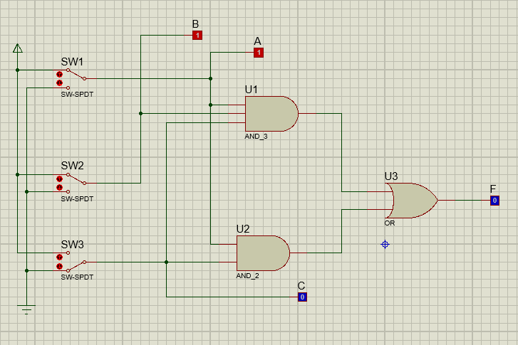

1. **Fungsi Boolean :** F = ABC+AC
2. **Tabel kebenaran**

|  |  |  |  |
| --- | --- | --- | --- |
| **A** | **B** | **C** | **F** |
| 0 | 0 | 0 | 0 |
| 1 | 0 | 0 | 0 |
| 0 | 1 | 0 | 0 |
| 1 | 1 | 0 | 0 |
| 0 | 0 | 1 | 0 |
| 1 | 0 | 1 | 1 |
| 0 | 1 | 1 | 0 |
| 1 | 1 | 1 | 1 |

1. **Karnaugh map**

|  |  |  |  |  |  |
| --- | --- | --- | --- | --- | --- |
|  | | **AB** | | | |
| **00** | **01** | **11** | **10** |
| **C** | **0** |  |  |  |  |
| **1** |  |  | **1** | **1** |

1. **Fungsi boolean berdasarkan karnaugh map:** AC
2. **Gerbang logika baru**

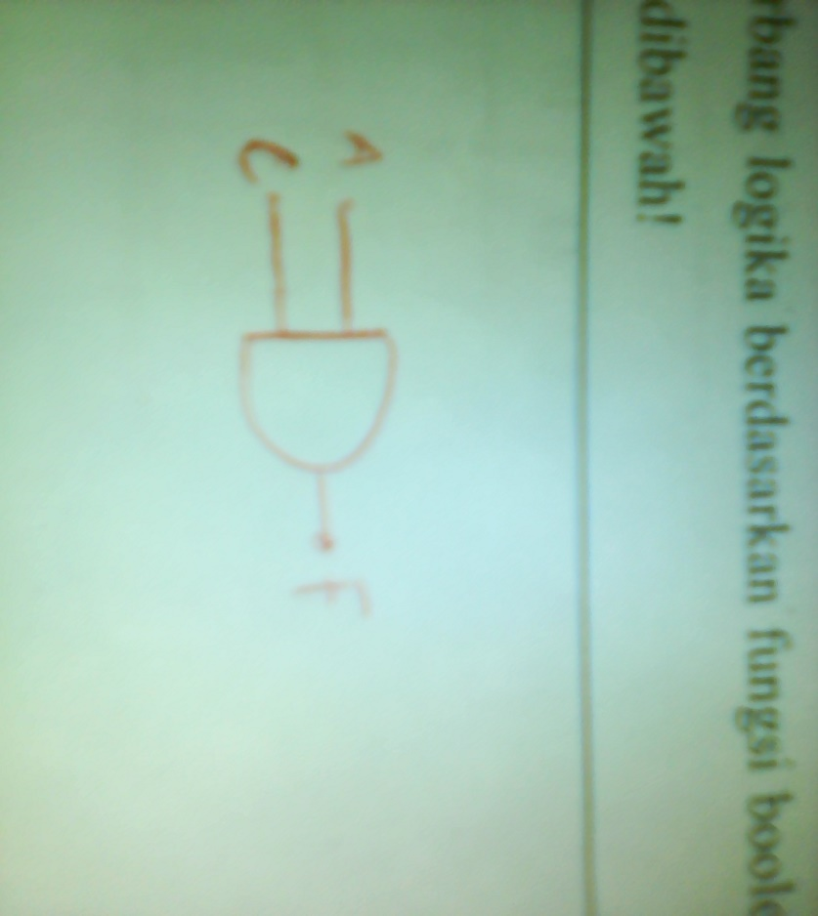

1. **Percobaan 2**
2. **Gerbang Logika**

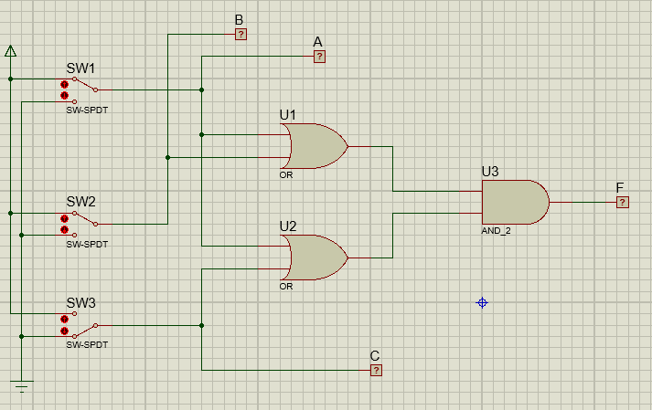

1. **Fungsi Boolean :** F = (A+B).(A+C)
2. **Tabel kebenaran**

|  |  |  |  |
| --- | --- | --- | --- |
| **A** | **B** | **C** | **F** |
| 0 | 0 | 0 | 0 |
| 1 | 0 | 0 | 1 |
| 0 | 1 | 0 | 0 |
| 1 | 1 | 0 | 1 |
| 0 | 0 | 1 | 0 |
| 1 | 0 | 1 | 1 |
| 0 | 1 | 1 | 1 |
| 1 | 1 | 1 | 1 |

1. **Karnaugh map**

|  |  |  |  |  |  |
| --- | --- | --- | --- | --- | --- |
|  | | **AB** | | | |
| **00** | **01** | **11** | **10** |
| **C** | **0** |  |  | **1** | **1** |
| **1** | **1** | **1** | **1** | **1** |

1. **Fungsi boolean berdasarkan karnaugh map:** A+BC
2. **Gerbang logika baru**

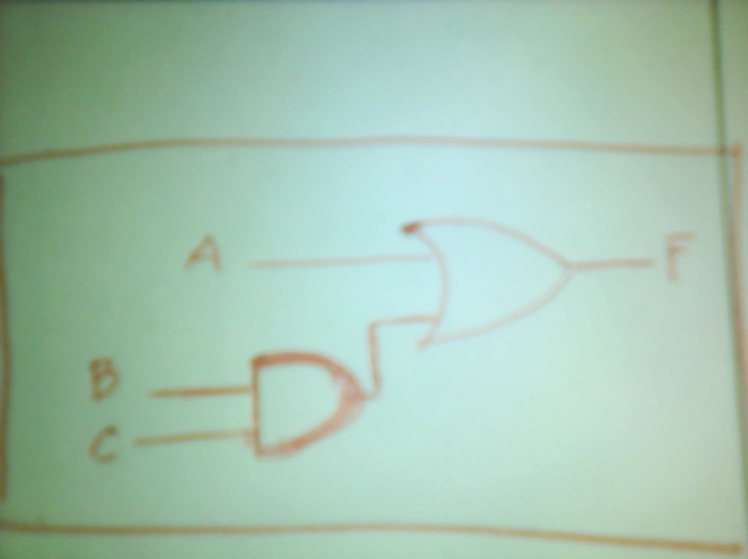

1. **Percobaan 3**
2. **Gerbang Logika**

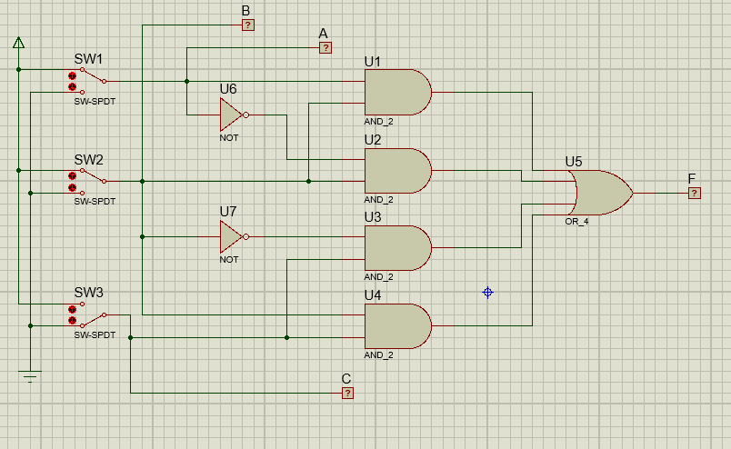

1. **Fungsi Boolean :** F= AB+A’B+B’C+BC
2. **Tabel kebenaran**

|  |  |  |  |
| --- | --- | --- | --- |
| **A** | **B** | **C** | **F** |
| 0 | 0 | 0 | 0 |
| 1 | 0 | 0 | 0 |
| 0 | 1 | 0 | 1 |
| 1 | 1 | 0 | 1 |
| 0 | 0 | 1 | 1 |
| 1 | 0 | 1 | 1 |
| 0 | 1 | 1 | 1 |
| 1 | 1 | 1 | 1 |

1. **Karnaugh map**

|  |  |  |  |  |  |
| --- | --- | --- | --- | --- | --- |
|  | | **AB** | | | |
| **00** | **01** | **11** | **10** |
| **C** | **0** |  | **1** | **1** |  |
| **1** | **1** | **1** | **1** | **1** |

1. **Fungsi boolean berdasarkan karnaugh map:** B+C
2. **Gerbang logika baru**

